Electrical thermometers down to
ambient temperatures of -60 °C

Klingenberg, May 2018.
WIKA now also offers electrical thermometers in a version for ambient temperatures down to -60 °C. This version has been tailored for applications in the crude oil, natural gas and petrochemical industries in polar climates.

The thermometers for extreme cold do not differ, neither in their external appearance nor in their accuracy, from standard instruments for ambient temperatures down to -40 °C. However, these are individual solutions made of application-specific and appropriately cold-resistant components.

Each ready-to-use thermometer and its components are tested, in line with the requirements, at a test temperature of -70 °C, for thermal shock resistance in accordance with IEC 60079-0 and for an IP protection in accordance with IEC 60529. An impact resistance test is added with the assembled instrument. The qualification for low ambient temperatures is confirmed on the delivery note.

Number of characters: 902
Key words: Electrical thermometers for ambient temperatures down to -60 °C

Manufacturer:
WIKA Alexander Wiegand SE & Co. KG
Alexander-Wiegand-Straße 30
63911 Klingenberg/Germany
Tel. +49 9372 132-0
Fax +49 9372 132-406
vertrieb@wika.com
www.wika.de

WIKA company photograph:
Electrical thermometers for ambient temperatures down to -60 °C

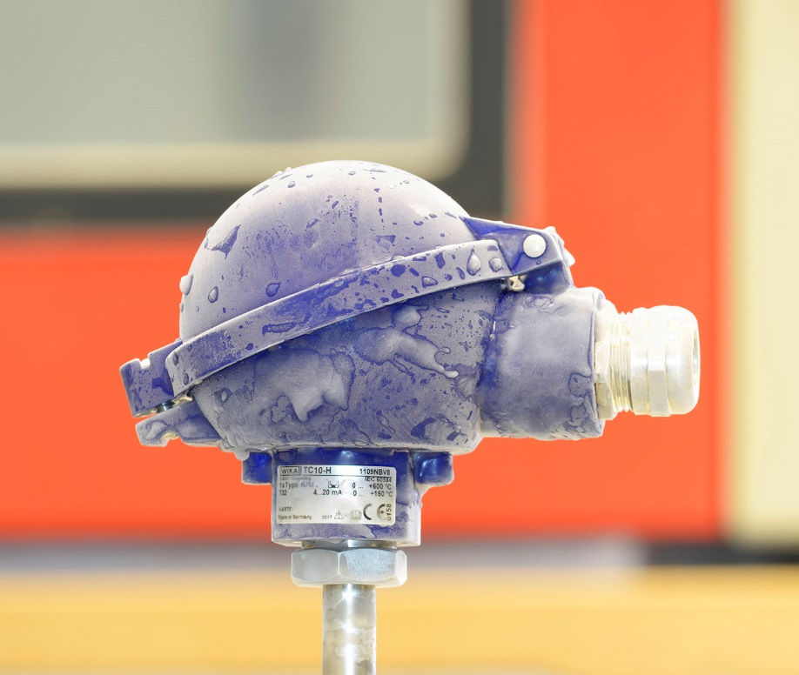

Edited by:
WIKA Alexander Wiegand SE & Co. KG
André Habel Nunes
Marketing Services
Alexander-Wiegand-Straße 30
63911 Klingenberg/Germany
Tel. +49 9372 132-8010
Fax +49 9372 132-8008010
andre.habel-nunes@wika.com
www.wika.de

WIKA press release 05/2018

