Compact ball valve
also for heavy-duty applications

Klingenberg, June 2020. As first shut-off valve or for connecting pressure measuring instruments: The new ball valve, model BV, is suitable for a variety of applications. It is available in process and instrument versions.

The instrumentation valve is compact and can therefore also be integrated in space-restricted environments, like a control panel. Thanks to its robustness, the model BV is suitable for heavy-duty applications and processes with critical media. Its pressurised parts correspond to the safety factor 4:1, its leak tightness has been tested in accordance with BS 6755 / ISO 5208, leakage rate A. An antistatic design, a blow-out-proof valve spindle and self-relieving valve seats ensure the safe operation of the ball valve. The high-quality processing of the inner parts also enables constant precise and smooth operation.

For the model BV, WIKA offers an application-specific assembly with a measuring instrument. Such an instrument hook-up is delivered ready-to-install and leak tested.

Number of characters: 983
Key word: BV

Manufacturer:
WIKA Alexander Wiegand SE & Co. KG
Alexander-Wiegand-Straße 30
63911 Klingenberg/Germany
Tel. +49 9372 132-0
Fax +49 9372 132-406
vertrieb@wika.com
www.wika.de
WIKA company photograph:
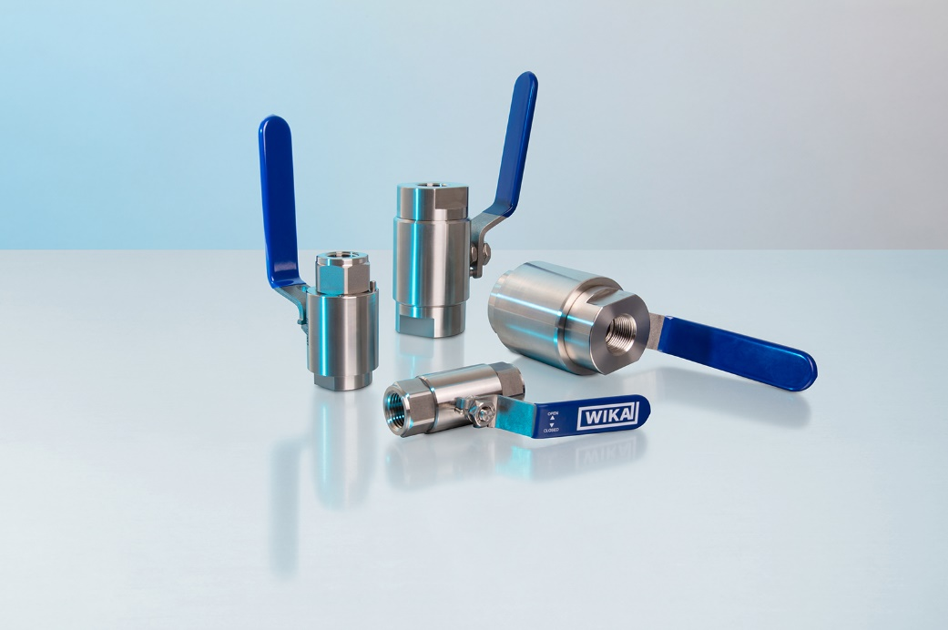
Typ: BV

Edited by:
WIKA Alexander Wiegand SE & Co. KG
André Habel Nunes
Marketing Services
Alexander-Wiegand-Straße 30
63911 Klingenberg/Germany
Tel. +49 9372 132-8010
Fax +49 9372 132-8008010
andre.habel-nunes@wika.com
www.wika.de

WIKA press release

