New temperature transmitter is
highly accurate, fast and extremely EMC resistant
Klingenberg, November 2015.
WIKA has developed a new digital temperature transmitter, model T15, in a head-mounted and rail-mounted version - with more-powerful electronics and optimised case design.

The new transmitter with analogue output processes signals from resistance sensors (Pt100 and Pt1000) and potentiometers. It is ready for operation in less than three seconds and offers a high basic accuracy of 0.1 % of span at a measuring rate of up to 20 measured values per second. At the same time, the T15 fulfils high standards of safety, for example in accordance with NAMUR recommendations on EMC protection, signalling and sensor-break monitoring. It is the first transmitter on the market to be certified to the new EMC protection standard, DIN EN 61326-2-3:2013. In addition, the T15 offers ATEX and IECEx approvals for use in hazardous areas.

With the new WIKAsoft-TT software, the transmitter can be programmed intuitively. The simple operation of the T15 is supported through a case with sensor connection from the outside, a large clamping area of up to 2.5 mm², and also an imprinted pin assignment. The new, cost-effective instrument can be used for diverse applications in machine building and plant construction, and also in the process industry.

Number of characters: 1233
Key word: T15

Manufacturer:
WIKA Alexander Wiegand SE & Co. KG
Alexander-Wiegand-Straße 30
63911 Klingenberg/Germany
Tel. +49 9372 132-0
Fax +49 9372 132-406
vertrieb@wika.com
www.wika.de

WIKA company photograph:
Temperature transmitter, model T15, head and rail version

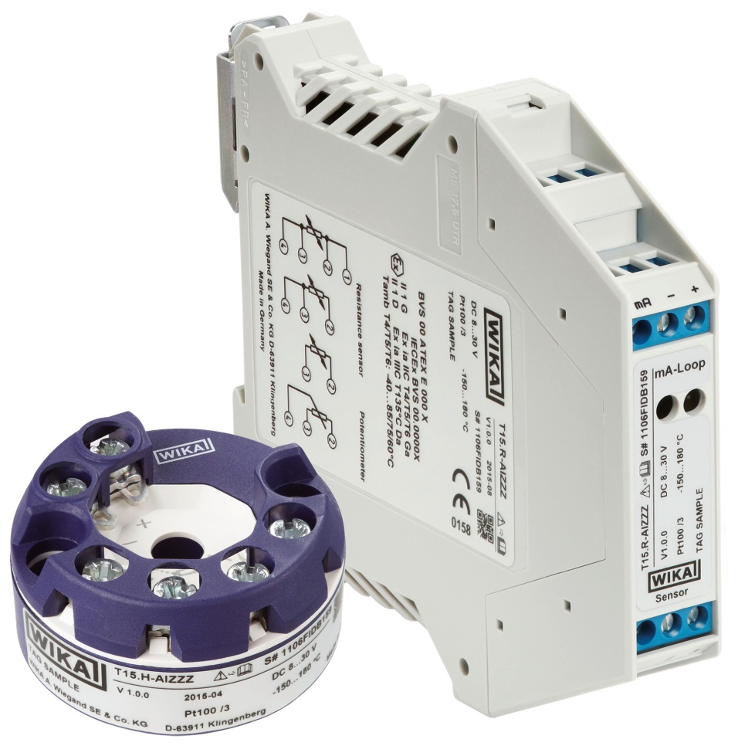

Edited by:
WIKA Alexander Wiegand SE & Co. KG
André Habel Nunes
Marketing Services
Alexander-Wiegand-Straße 30
63911 Klingenberg/Germany
Tel. +49 9372 132-8010
Fax +49 9372 132-8008010
andre.habel-nunes@wika.com
www.wika.de

WIKA press release 23/2015

