New controller with larger pressure range and additional test applications

Klingenberg, November 2015.
In the CPC6050, WIKA is introducing a new modular pressure controller with enhanced performance capabilities. The successor to the CPC6000 offers an extended pressure range of up to 210 bar and new test applications: leak testing, switch testing and burst testing.

The intuitive CPC6050 is available with a maximum of two independent channels, each of which can accommodate up to two internal pressure sensors. Optionally, there is a version with a single output for a simultaneous access to both channels. The switchover takes place automatically via the AutoChannel function. As a result, the operator achieves a wide dynamic pressure range of 400:1.

With an accuracy of up to 0.01 % IS-50, the CPC6050 is primarily suitable as a reference instrument for calibration laboratories and production processes. Due to the AutoChannel function and a high control stability of < 0.003 % FS, it is also an ideal solution for calibration and test applications in healthcare and in the aviation industry. The new controller communicates with other instruments, depending on selection, via IEEE-488, RS-232, USB (optionally with WiFi adapter) or Ethernet.

Number of characters: 1143
Key word: CPC6050

Manufacturer:
WIKA Alexander Wiegand SE & Co. KG
Alexander-Wiegand-Straße 30
63911 Klingenberg/Germany
Tel. +49 9372 132-0
Fax +49 9372 132-406
vertrieb@wika.com
www.wika.de

WIKA company photograph:
WIKA pressure controller CPC6050

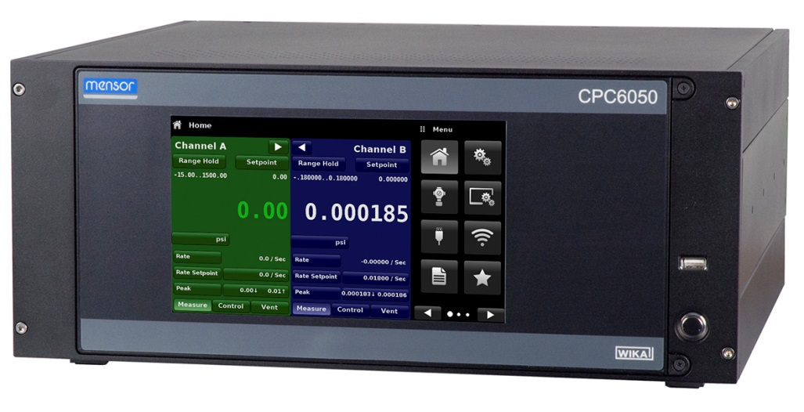

Edited by:
WIKA Alexander Wiegand SE & Co. KG
André Habel Nunes
Marketing Services
Alexander-Wiegand-Straße 30
63911 Klingenberg/Germany
Tel. +49 9372 132-8010
Fax +49 9372 132-8008010
andre.habel-nunes@wika.com
www.wika.de

WIKA press release 24/2015

